**Practice-1**

**Aim: WAP to create a class Employee with setter and getter. Which have fields like id, name, role, salary, experience, address, email and contact. Get 5 records.**

**Promgram:**

#include<iostream>

using namespace std;

class employee

{

private:

char emp_name[100]; int emp_id;

char emp_role[100]; int emp_salary;

char emp_email[100]; int emp_experience;

char emp_adress[100]; double emp_contact_no;

public:

void setdata()

{

cout << "enter employee ID :"; cin>>this->emp_id ;

cout << "enter employee NAME :"; cin>>this->emp_name;

cout << "enter employee Salary :"; cin>>this->emp_salary;

cout << "enter employee ROLE:"; cin>>this->emp_role;

cout << "enter employee EMAIL:"; cin>>this->emp_email;

cout << "enter employee Adress:"; cin>>this->emp_adress;

cout << "enter employee EXPERIENCE:"; cin>>this->emp_experience;

cout << "enter employee Contact number:"; cin>>this->emp_contact_no;

cout << "------------------------------------------------------" <<endl;

}

void getdata()

{

cout << "ID ::"<<this->emp_id<<endl;

cout << "NAME ::"<<this->emp_name<<endl;

cout << "SALARY ::"<<this->emp_salary<<endl;

cout << "ROLE ::"<<this->emp_role<<endl;

cout << "EMAIL ::"<<this->emp_email<<endl;

cout << "ADRESS ::"<<this->emp_adress<<endl;

cout << "EXPERIENCE ::"<<this->emp_experience<<endl;

cout << "CONTACT NO. ::"<<this->emp_contact_no<<endl;

cout << "------------------------------------------------------" <<endl;

}

};

int main()

{

employee e[5];

int i,n;

cout << "how many employees : "; cin >> n ;

cout << "------------------------------------------------------" <<endl;

for(i=0; i<n; i++)

{

e[i].setdata();

}

cout << "------------------------------------------------------" <<endl;

cout << "------------------------------------------------------" <<endl;

cout << "------------------------------------------------------" <<endl;

cout << "------------------------------------------------------" <<endl;

for(i=0; i<n; i++)

{

e[i].getdata();

}

return 0;

}

**Output:**

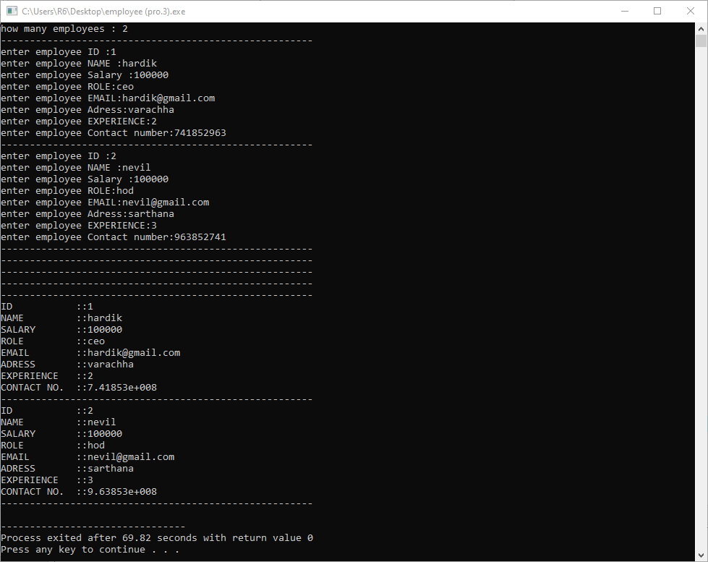

**Practice-2**

**Aim:WAP to create a class which Read and print Class, Student details using Two Classes. (Make two classes, create one classe's obj in another class.)**

**Promgram:**

#include<iostream>

using namespace std;

class Classroom

{

private :

char cls_name[100];

public :

void setclassroom()

{

cout << "------------------------------------------------------" << endl ;

cout << "Enter Class Name: " ; cin >> cls_name;

}

void getclassroom()

{

cout << "Class name is: " << cls_name << endl;

}

};

class Students

{

Classroom c;

private :

char name[100];

int Grid;

char cr[100];

char sur_name[100];

public :

void setStudents()

{

c.setclassroom();

cout << "Enter NAME:: " ; cin >> this->name;

cout << "Enter SUR NAME:: " ; cin >> this->sur_name;

cout << "Enter GRID:: " ; cin >> this->Grid;

cout << "Enter CLASS REPRESENTETIVE NAME : " ; cin >> this->cr;

}

void getStudents()

{

c.getclassroom();

cout << "NAME: " << this->name << endl;

cout << "SUR NAME: " << this->sur_name << endl;

cout << "GRID: " << this->Grid << endl;

cout << "CLASS REPRESENTETIVE:" << this->cr << endl;

}

};

int main()

{

Students s[100];

int i,n;

cout << "How Many Students : "; cin >> n;

for(i=0;i<n;i++)

{

s[i].setStudents();

}

cout << "------------------------------------------------------" << endl ;

cout << "------------------------------------------------------" << endl ;

cout << "------------------------------------------------------" << endl ;

for(i=0;i<n;i++)

{

s[i].getStudents();

cout << "------------------------------------------------------" << endl ;

}

return 0;

}

**Output:**

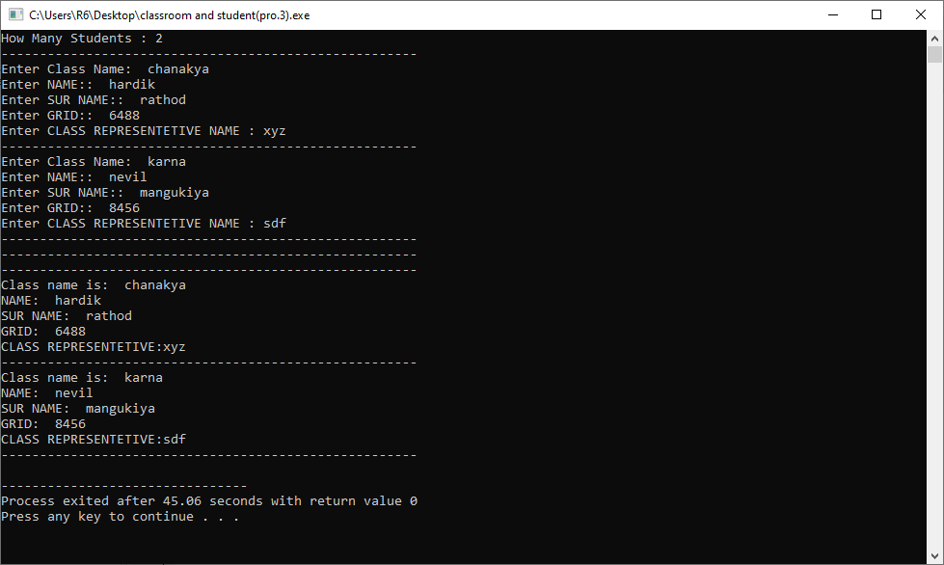

**Practice-3**

**Aim:WAP to create a class Hotel with fields like id, name, type, staff_size, room_size, establish_year, address, rating_type and website. Illustrate the use of encapsulation (strict encapsulation) with this keyword.**

**Promgram:**

#include<iostream>

using namespace std;

class Hotel

{

private:

int staff_size; char name[100];

int room_size; char type[100];

int establish_year; char address[100];

int rating_type; char website[100];

int id;

public:

void setData()

{

cout << "Enter Hotel details : "<< endl << endl;

cout << "Enter id : "; cin >> this->id;

cout << "Enter hotel name : "; cin >> this->name;

cout << "Enter hotel type : "; cin >> this-> type;

cout << "Enter hotel staff size : "; cin >> this->staff_size;

cout << "Enter hotel room size : "; cin >> this->room_size;

cout << "Enter hotel establish year : "; cin >> this->establish_year;

cout << "Enter hotel address :-"; cin >> this->address;

cout << "Enter hotel rating type : "; cin >> this->rating_type;

cout << "Enter hotel website : "; cin >> this->website;

cout << endl << "----------------------------------------------" << endl;

}

void getData()

{

cout << endl << endl << "Hotel details : " << endl << endl;

cout << "Hotel id : " << this->id << endl;

cout << "Hotel name : " << this->name << endl;

cout << "Hotel type : " << this-> type << endl;

cout << "Hotel staff size : " << this->staff_size << endl;

cout << "Hotel room size : " << this->room_size << endl;

cout << "Hotel establish year : " << this->establish_year << endl;

cout << "Hotel address : " << this->address << endl;

cout << "Hotel rating type : " << this->rating_type << endl;

cout << "Hotel website : " << this->website << endl;

cout << endl << "----------------------------------------------" << endl ;

}

};

int main()

{

Hotel h[100];

int i,n;

cout << "how many hotels surveys ::: "; cin >> n;

cout << endl;

for(i=0;i<n;i++)

{

h[i].setData();

}

cout << endl << "----------------------------------------------" << endl << endl;

cout << endl << "----------------------------------------------" << endl << endl;

cout << endl << "----------------------------------------------" << endl << endl;

for(i=0;i<n;i++)

{

h[i].getData();

}

return 0;

}

**Output:**

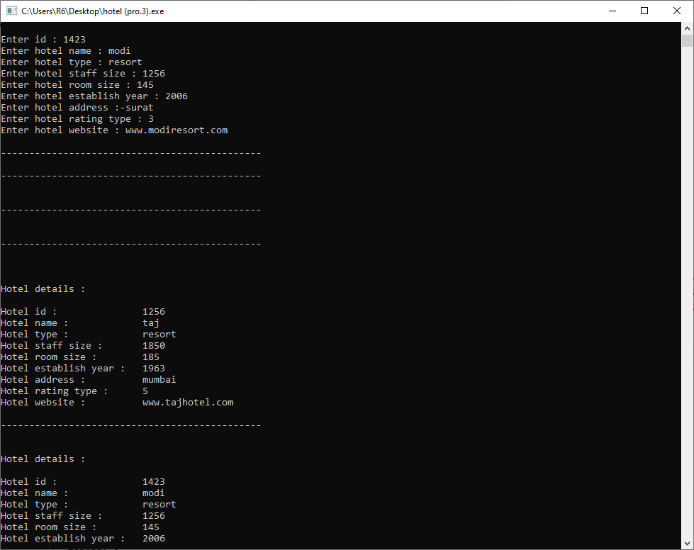

**Practice-4**

**Aim:WAP to create two class HighSchool and College with fields like id, stu_name, stu_roll_no, stu_standard, stu_age, stu_contact, stu_edu_institute_name and stu_address. Make suitable setter and getter with use of static data members.**

**Promgram:**

#include<iostream>

#include<string.h>

using namespace std;

class school

{

private :

int id; char student_name[100];

int student_roll_no; char student_address[100];

int student_standard;

int student_age;

int student_contact;

public :

static char school_name[100];

public :

void setData()

{

cout << "---------------------------------------------------------------" << endl;

cout << "enter school details :::::::" << endl << endl;

cout << "Enter Id :"; cin >> this->id;

cout << "Enter students name :"; cin >> this->student_name;

cout << "Enter Roll no. :"; cin >> this->student_roll_no;

cout << "Enter Standard :"; cin >> this->student_standard;

cout << "Enter Age :"; cin >> this->student_age;

cout << "Enter Contact :"; cin >> this->student_contact;

cout << "Enter Address :"; cin >> this->student_address;

}

void getData()

{

cout << "---------------------------------------------------------------" << endl;

cout << "ID: " << this->id << endl;

cout << "NAME: " << this->student_name<< endl;

cout << "ROLL NO: " << this->student_roll_no<< endl;

cout << "STANDARD: " << this->student_standard<< endl;

cout << "AGE: " << this->student_age<< endl;

cout << "CONTACT: " << this->student_contact<< endl;

cout << "ADDRESS: " << this->student_address<< endl;

cout << "INSTITUTE NAME: " << this->school_name<< endl;

}

};

class collage

{ school p;

private :

int id; char student_name[100];

int student_age; char student_address[100];

int student_contact;

public :

static char collage_name[100];

public :

void setData()

{

p.setData();

cout << "---------------------------------------------------------------" << endl;

cout << "enter collage details:::::::" << endl << endl ;

cout << "Enter Id :"; cin >> this->id;

cout << "Enter students name :"; cin >> this->student_name;

cout << "Enter Age :"; cin >> this->student_age;

cout << "Enter Contact :"; cin >> this->student_contact;

cout << "Enter Address :"; cin >> this->student_address;

}

void getData()

{

p.getData();

cout << "---------------------------------------------------------------" << endl;

cout << "ID: " << this->id << endl;

cout << "NAME: " << this->student_name<< endl;

cout << "AGE: " << this->student_age<< endl;

cout << "CONTACT: " << this->student_contact<< endl;

cout << "ADDRESS: " << this->student_address<< endl;

cout << "COLLAGE NAME: " << this->collage_name<< endl;

}

};

char school::school_name[100]="navsarjan vidhyalaya";

char collage::collage_name[100]="rnwiet";

int main()

{

school::school_name;

collage h[100];

int i,n;

cout << "How Many Students:: "; cin >> n;

for(i=0;i<n;i++)

{

h[i].setData();

}

cout << "---------------------------------------------------------------" << endl;

cout << "---------------------------------------------------------------" << endl;

cout << "---------------------------------------------------------------" << endl;

for(i=0;i<n;i++)

{

h[i].getData();

}

return 0;

}

**Output:**

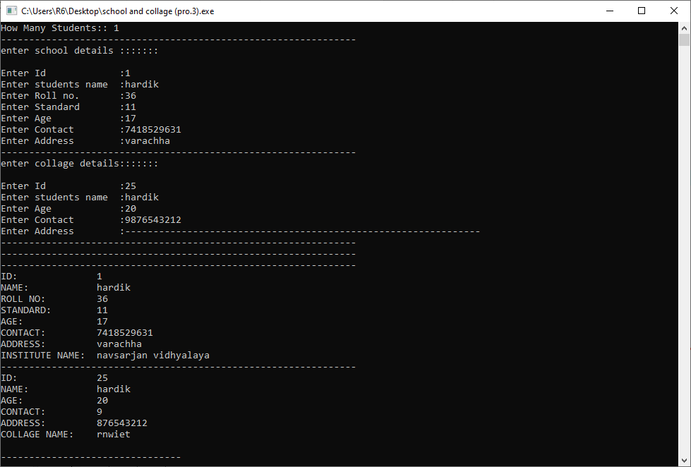

**Practice-5**

**Aim: WAP to create a class which have both static data member and static member function. That class gives details of all states in India.**

**Promgram:**

#include<iostream>

using namespace std;

class stateofindia

{

private:

static char s[29][50];

public:

static void getdata()

{

int i,j;

for(i=0;i<29;i++)

{

for(j=0;s[i][j]!='\0';j++)

{

cout<<s[i][j];

}

cout<<endl;

}

}

};

char stateofindia::s[29][50]=

{

"Andhra Pradesh","Arunachal Pradesh","Assam",

"Bihar",

"Chhattisgarh",

"Goa","Gujarat",

"Haryana","Himachal Pradesh",

"Jammu and Kashmir","Jharkhand",

"Karnataka","Kerala",

"Madhya Pradesh","Maharashtra","Manipur","Meghalaya","Mizoram",

"Nagaland",

"Odisha",

"Punjab",

"Rajasthan",

"Sikkim",

"Tamil Nadu","Telangana","Tripura",

"Uttar Pradesh","Uttarakhand",

"West Bengal"

};

int main()

{

stateofindia::getdata();

return 0;

}

**Output:**

